1. The free energy change for a reaction ΔG is directly obtained at several temperatures and the following equation is obtained by curve fitting: ΔG= -1676990 - 16.65 T lnT + 366.7 T kJ/mol. Calculate ΔH and ΔS for the reaction at 400K. Will the reaction proceed spontaneously at this temperature?

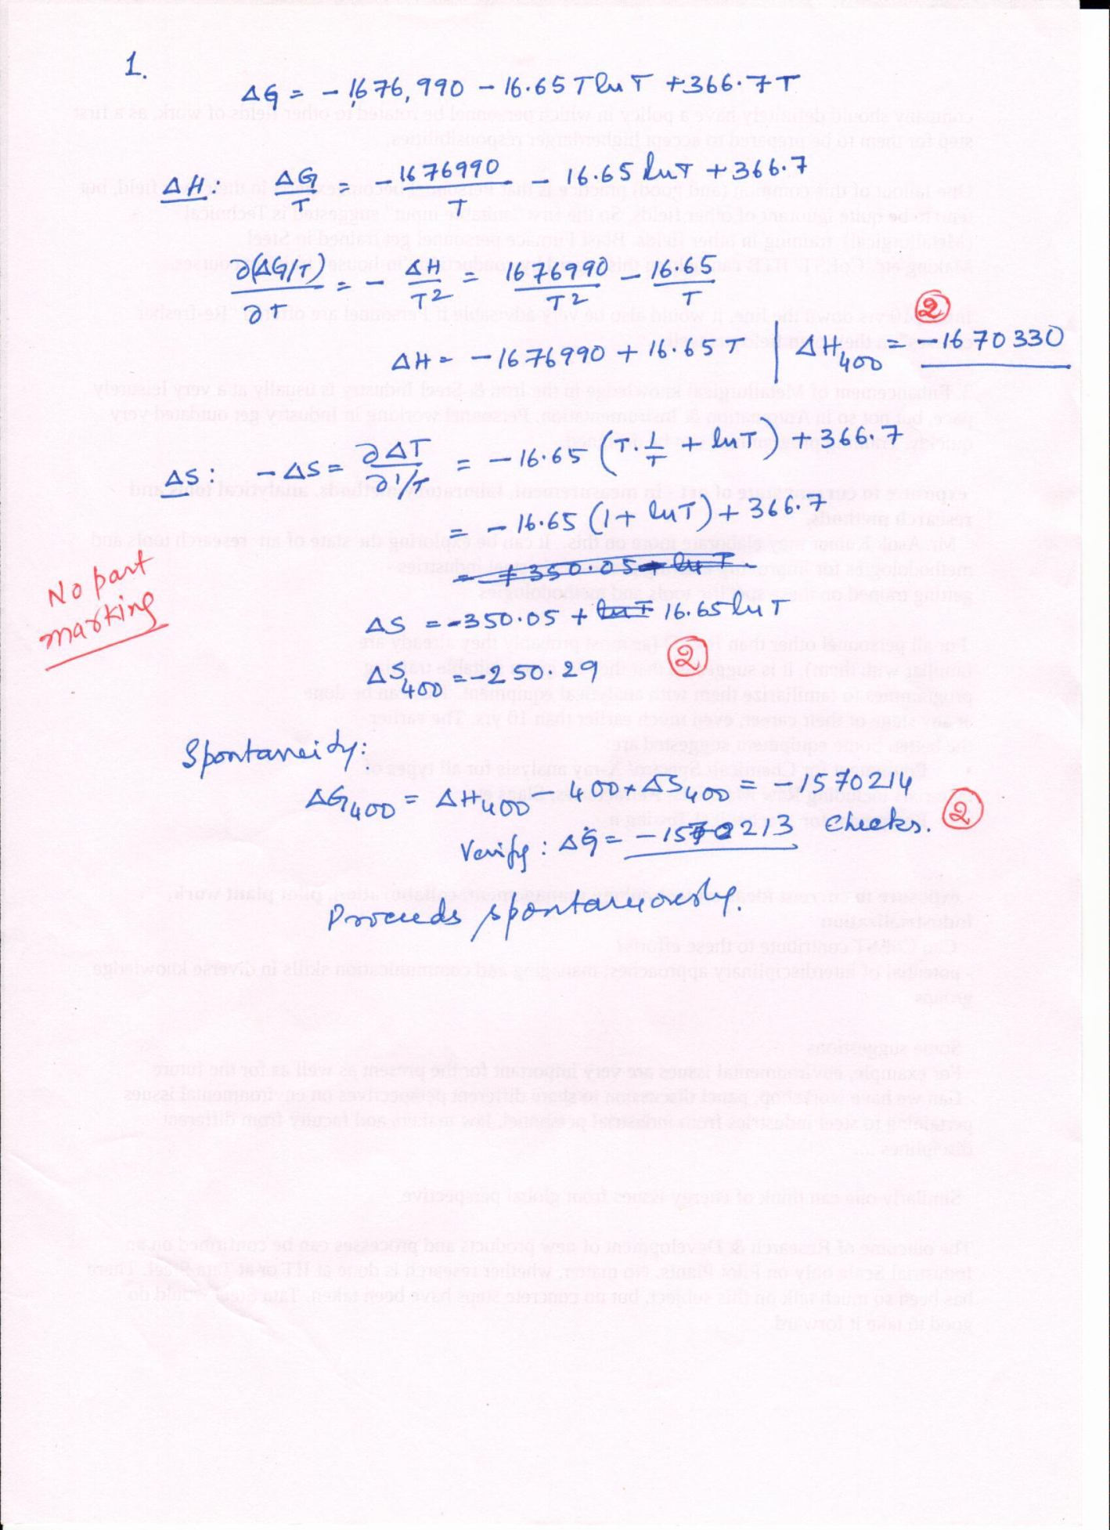

1. Carbon has two allotropes: graphite and diamond.
   1. Calculate the pressure that must be applied to graphite to convert it to diamond at 298K. Assume that the isothermal compressibility of the two phase to be negligible. (4 marks )
   2. What is the heat effect of conversion of 1 mol of graphite under this condition (2 marks)

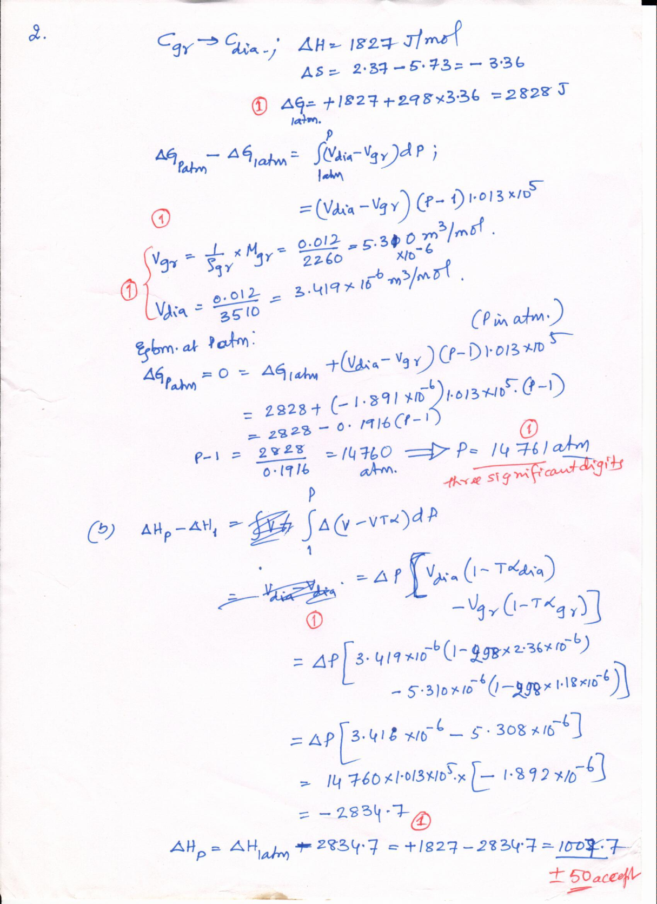

1. Calculate the entropy change for the following adiabatic processes:
   1. 10g of ice at 0oC is added to 100g of water at 80oC, all at 1atm.pressure, and allowed to homogenize. (3 marks)
   2. A 10kg weight at 300K falls through a distance of 10m into a water bath initially at 300K. Then the weight and the water come to a uniform temperature. Total heat capacity of water+weight may be taken as 500 J/ K (3 marks)

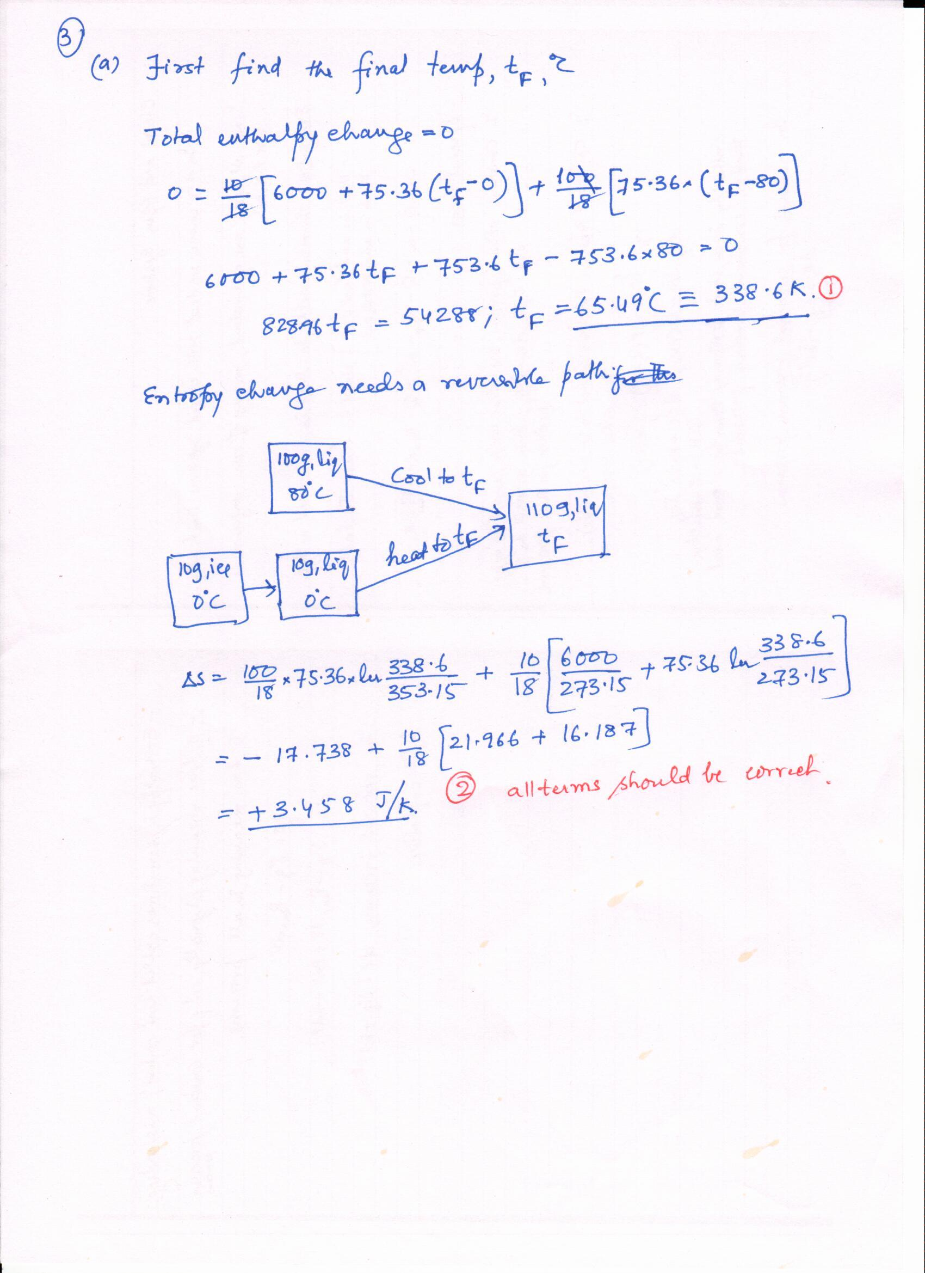

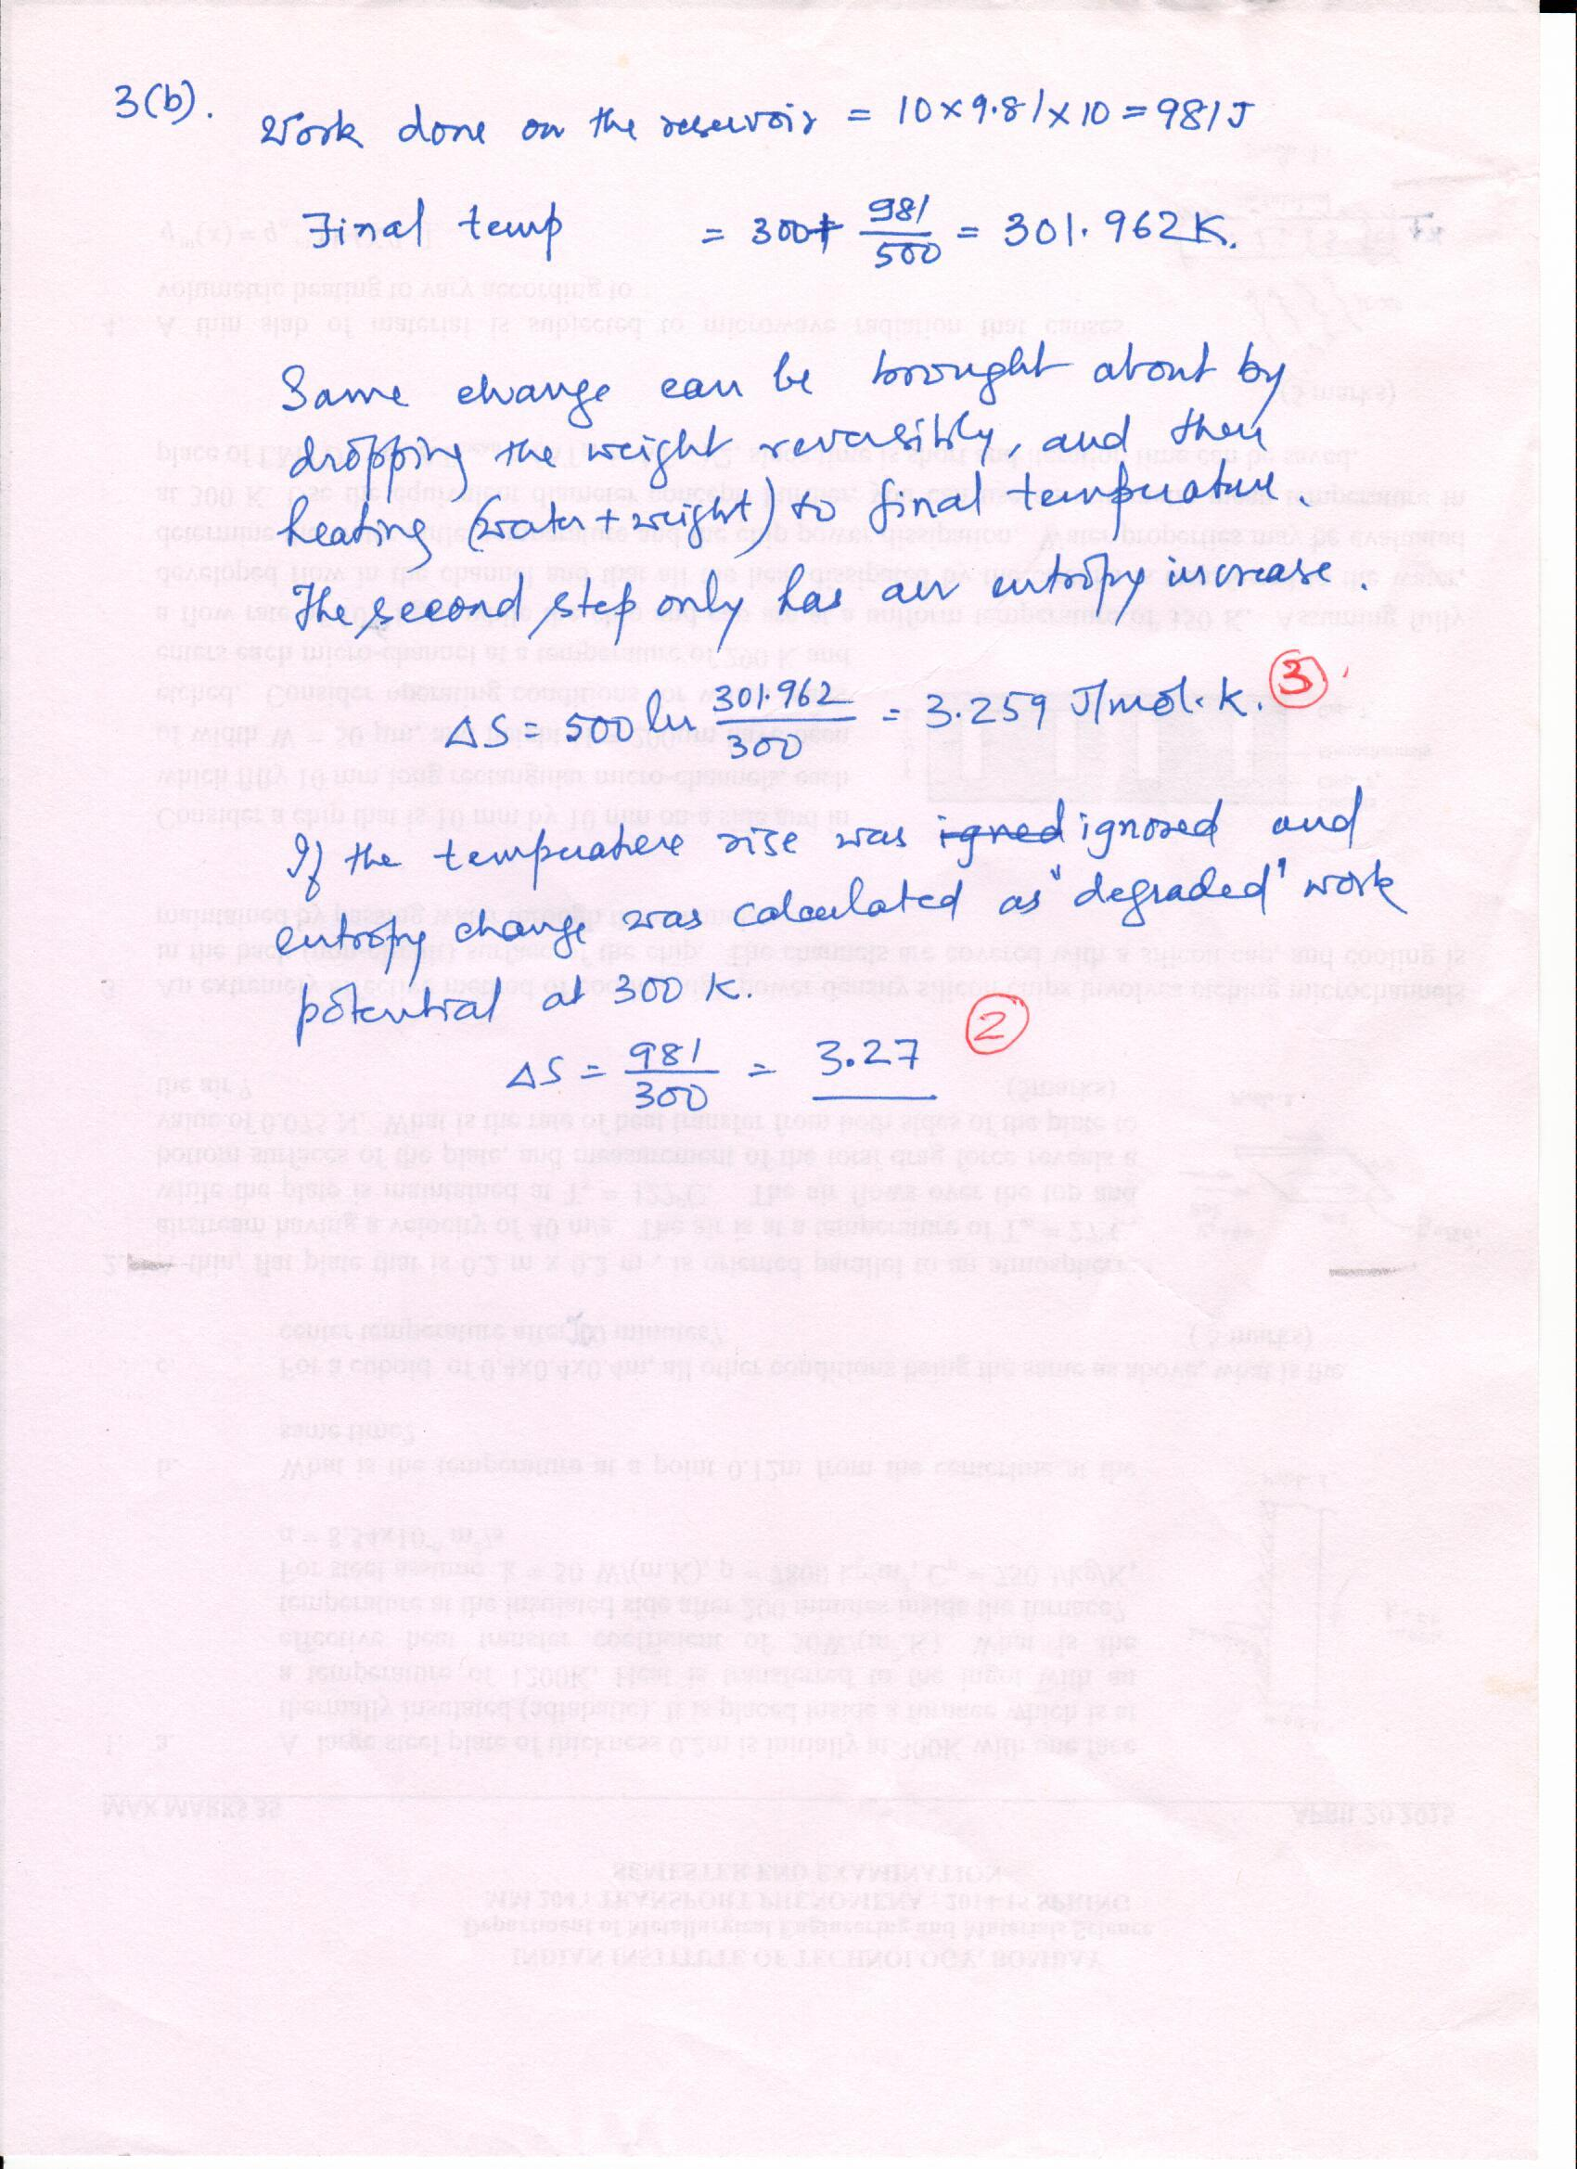

1. Derive the following using only the data given in this paper.
   1. $a) {\left(\frac{∂ \left(\frac{G}{T}\right)}{∂ \left(\frac{1}{T}\right)}\right)}_{P,ξ_{i}}=H$ (2 marks)
   2. b) $P=T{\left(\frac{∂P}{∂T}\right)}_{{V,ξ}_{i}}- {\left(\frac{∂E}{∂V}\right)}_{{T,ξ}_{i}}$ (2 marks)
   3. ${\left(\frac{∂T}{∂B}\right)}_{S}= -\frac{TVB}{C_{B}μ_{o}}{\left(\frac{∂χ}{∂T}\right)}_{B}$ where χ = $\frac{m μ_{o}}{VB}$ is the magnetic susceptibility and CB = (similar to Cp). (Only magnetic work : B.dm, positive when done **on** the system). (3 marks)

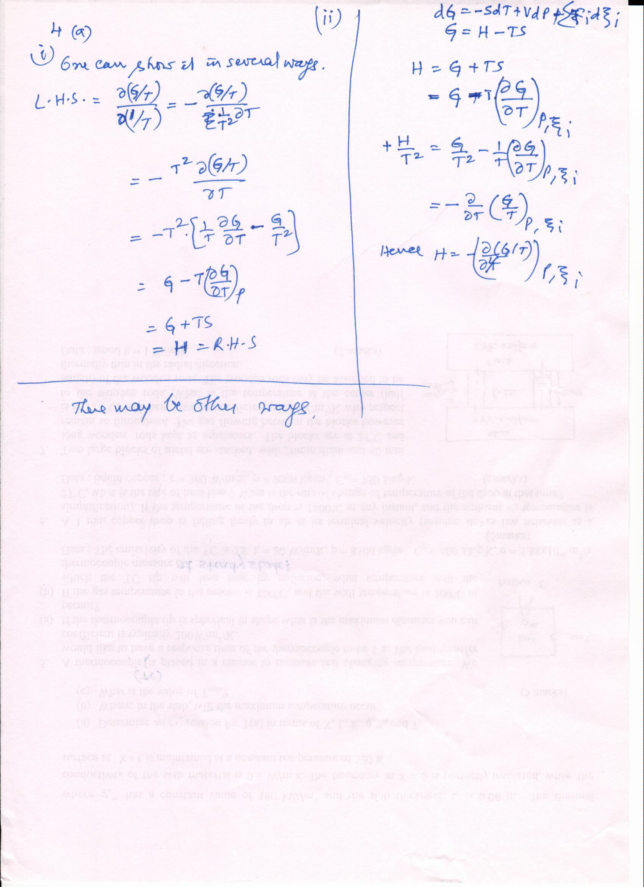

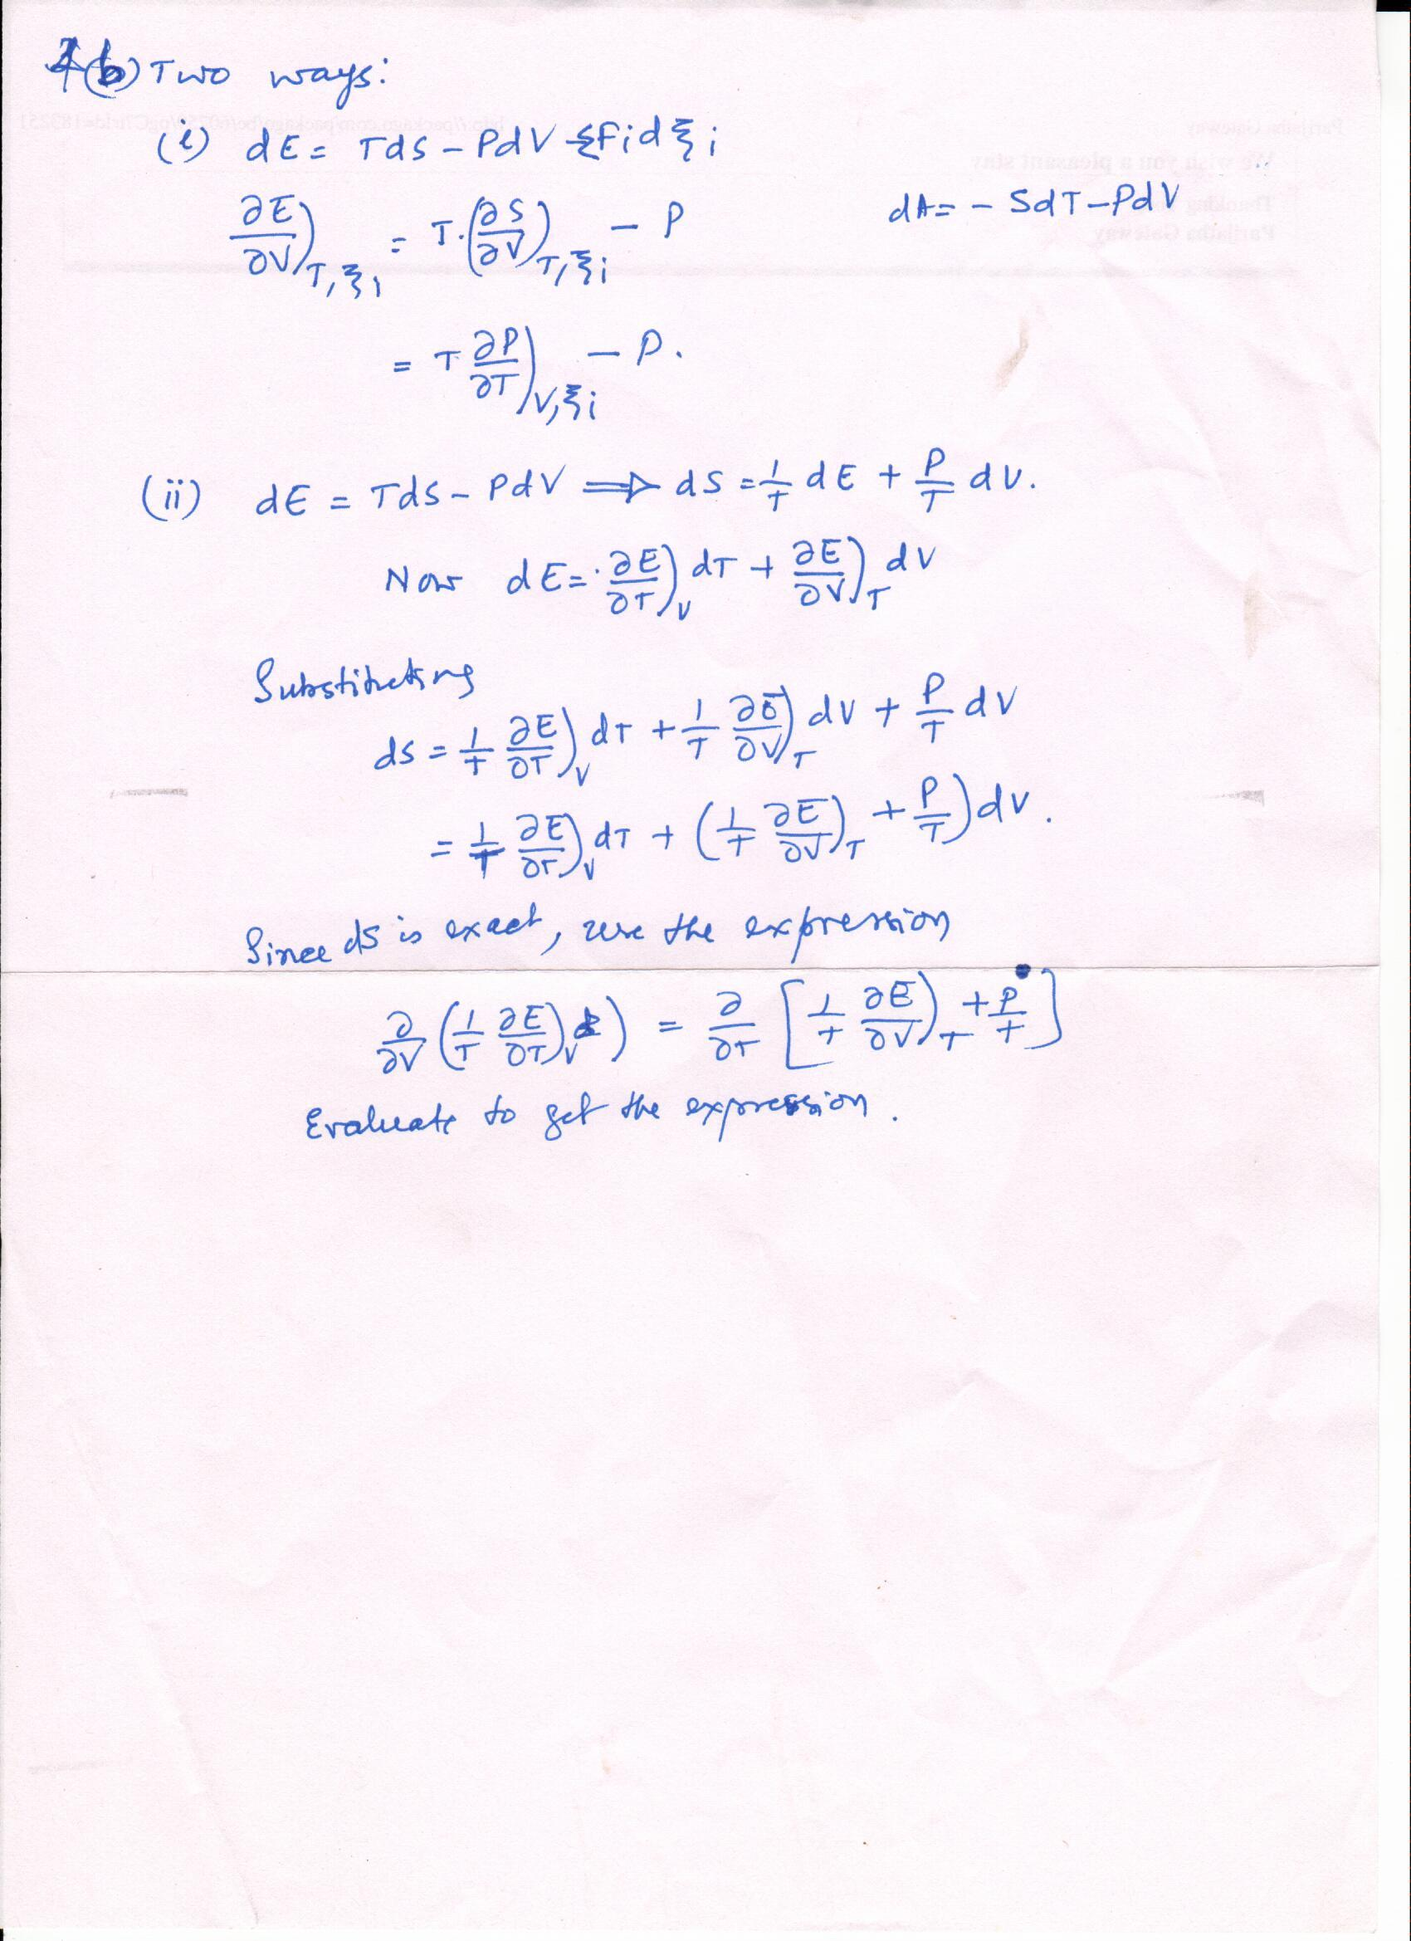

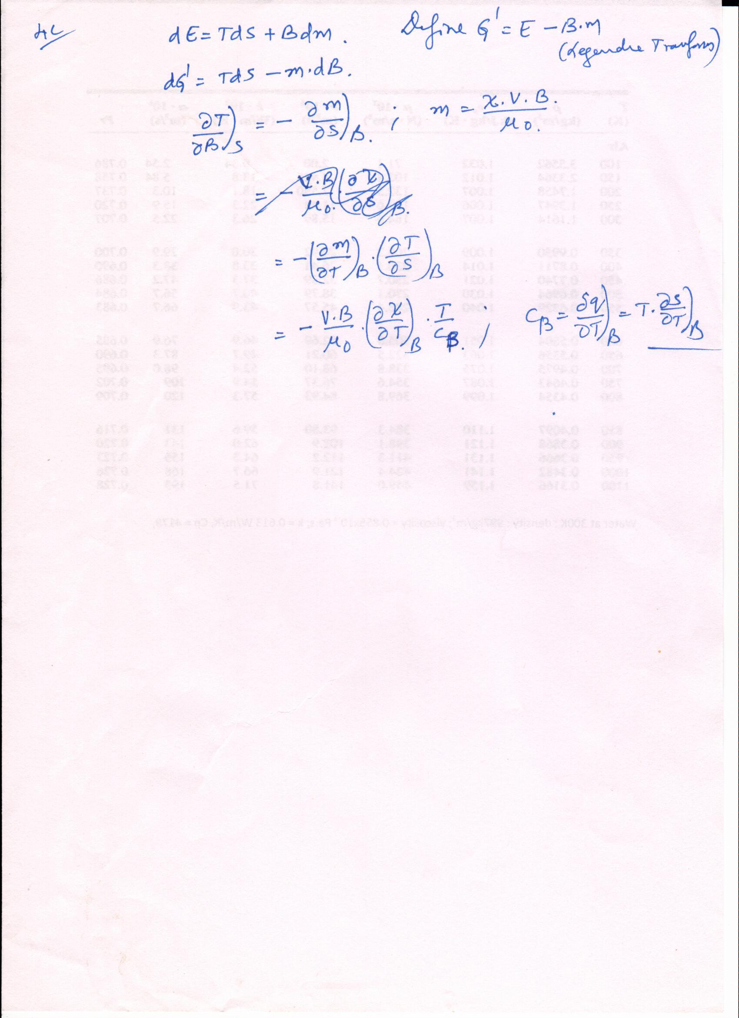

**BONUS:** 1 mole of calcined lime (CaO) is kept in a container containing CO2(g) at 1atm.pressure and 298K. Slowly lime picks up CO2 and gets converted to CaCO3(s), all at ~298K and 1 atm.pressure. (evidently this is not adiabatic, it is near isothermal. Calculate the entropy change in the system and the surrounding. (2+2 marks)

